# Getting access to Cyberark

Pre-Requisites

1. To get access to Cyberark portal, click on the self-service link and raise a Service Request ticket attaching Randy’s approval.
2. Search for the V-ID in QAR and add the group: [**gCybEPVr_EndUser_RADIUS**](http://activeroles/EmblemAdmin/GenerateForm.aspx?TaskId=GroupProperties&TargetClass=group&DN=CN%3dgCybEPVr_EndUser_RADIUS%2cOU%3dCyberArk%2cOU%3dApplication%2cOU%3dGroups%2cOU%3dAccounts%2cOU%3dCORP%2cDC%3dEMBLEM%2cDC%3dEMBLEMHEALTH%2cDC%3dCOM)
3. Once the group is added, please check for Duo access of the requestor.
4. To get access in Duo, click on the self-service link and raise a Service Request ticket and assign to InfoSec team.
5. Search for the V-ID in Duo security portal, if the user is not present, add the user in Duo.
6. Add the mobile number of the user, so that he\she can get Duo authentication call while logging to Cyberark.

Once the setups are done, advise the end user to login to Cyberark portal and check

<https://cyberark.emblemhealth.com/PasswordVault>

# Administration Using PrivateArk

* **Accessing the PrivateArk client**

Login to any PVWA boxes with Admin ID credentials. Select the Private Ark client to get access to vault

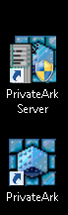

Once PrivateArk is selected, provide the credentials of the Administrator to access Vault.

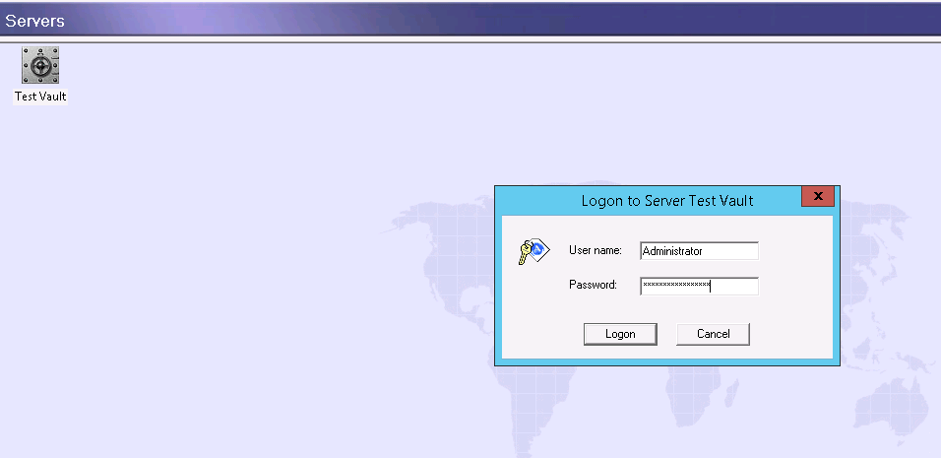

The Administrator logs in to the Vault environment and can view the displayed safes which are created.

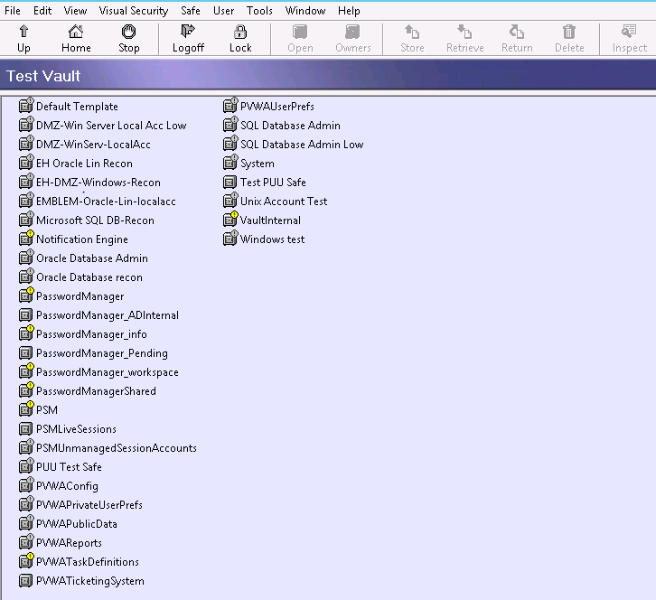

* **Search for Users/Groups**

Click on Tools🡪Administrative Tools🡪Users and Groups

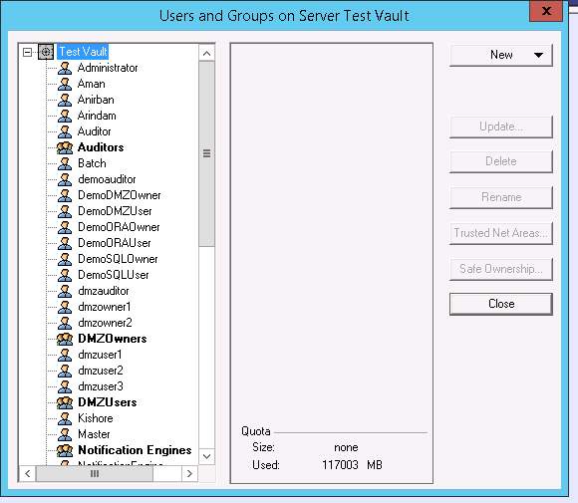

Groups are indicated by group people

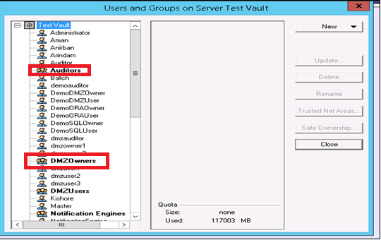

Under Test vault, the groups and the users are listed. Select the desired one to notify.

* **Create a User in PrivateArk**

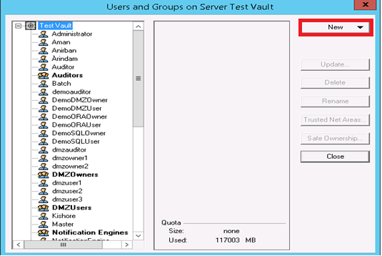

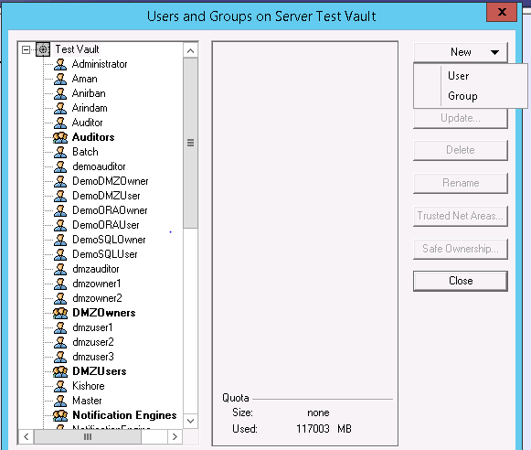

Provide the username to be created in Username section and select EPVUser in User Type dropdown.

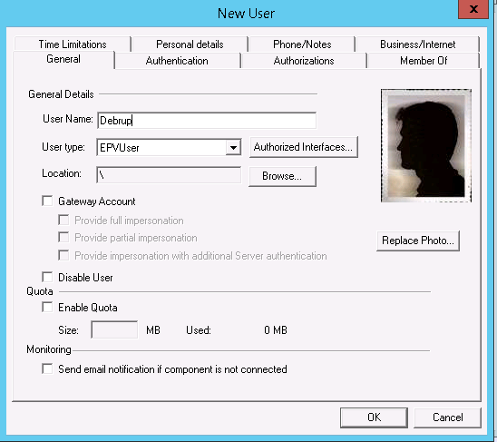

Set the password for the user, and set it to be never expiry:

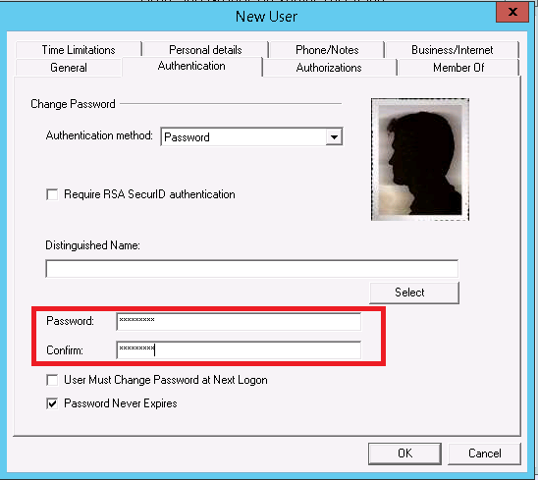

Set the Authorizations (permission) for the user

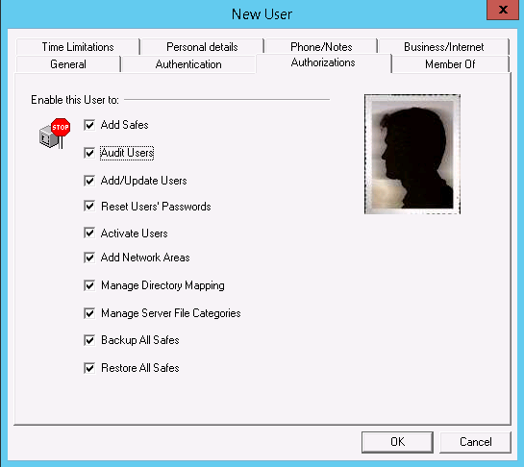

Set the Member of privileges groups from Available Groups

Select the required Group from Available Group and select Left arrow to add in Member Of section.

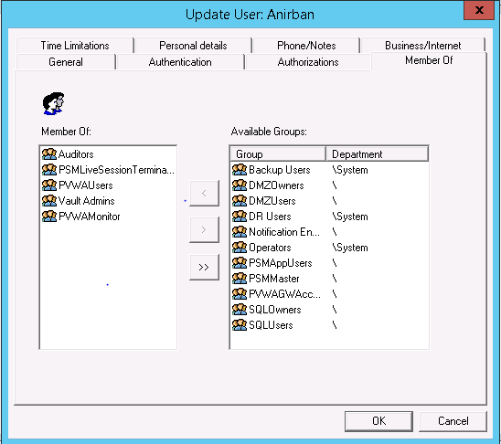

* **Create a Group in Private Ark**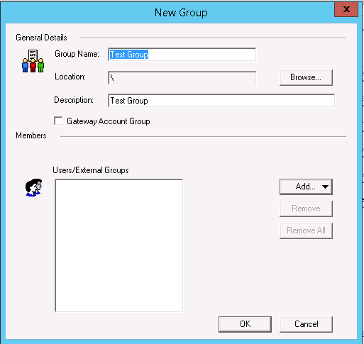

To add the users in the group, select Add:

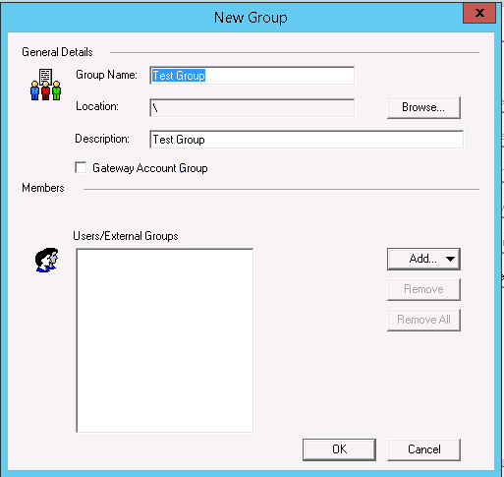

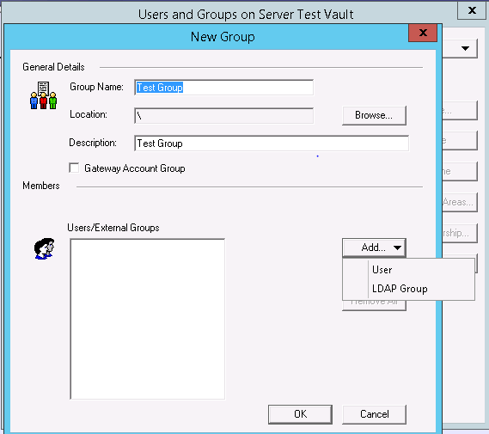

Select User to add users from Vault domain.

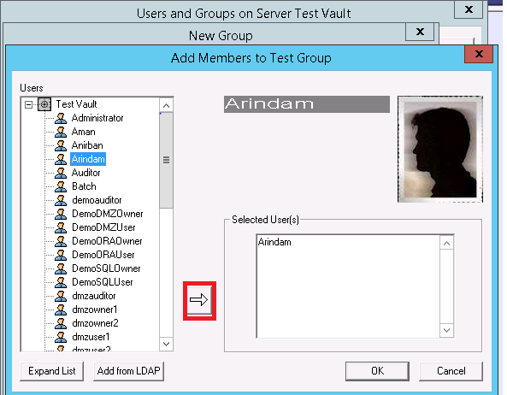

Select the required User from Vault domain, click on the right arrow and click OK to confirm the user to get added in the group.

* **Private Ark Reports**

Tools🡪Reports 🡪(Different types of Reports)

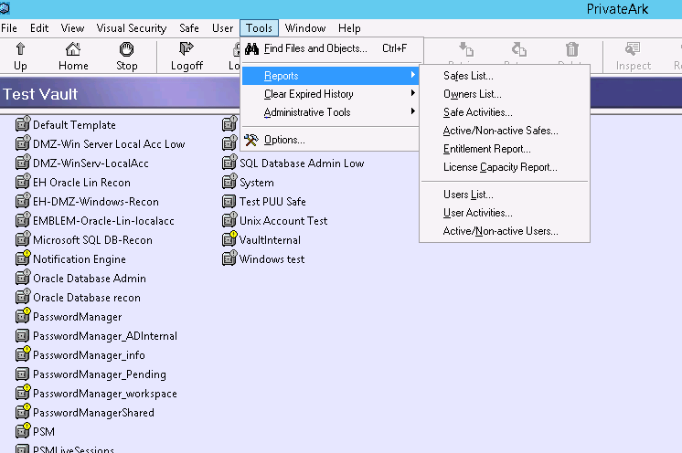

We have various types of Vault reports which one can pull by logging as Administrator:

**Safe List, Owners List, Safe Activities, Active/Non-active Safes, Entitlement Report, License capacity Report, Users List, User Activities, Active/Non-active users**

Below is an example of a Report type**:**

License capacity report: This report displays the maximum and used capacities for the Licensed Objects in Vault environment after installation.

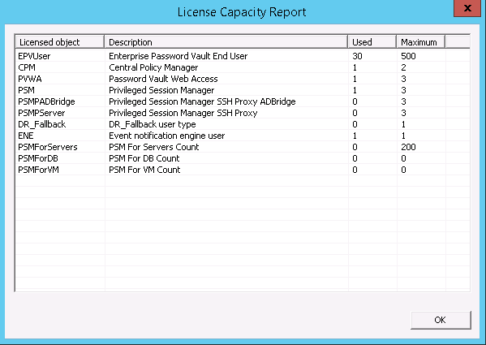

* **Unlocking a Local Administrator Password:**

Tools🡪Administrative Tools🡪Users and Groups-->select the <User name>

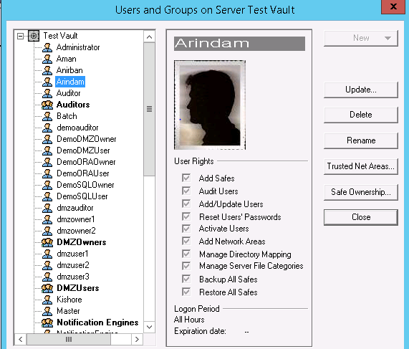

Find the username, click on it and open **Trusted Net Areas**

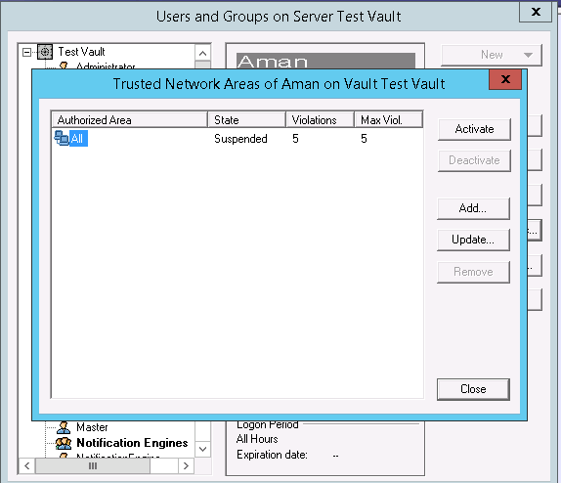

In the above screen shot, we can see that the username <Aman> has been suspended due to

**Five** incorrect login. To make the username enabled, click on **Activate** and this will make the username active.

**Reports:**

**Safe List:**

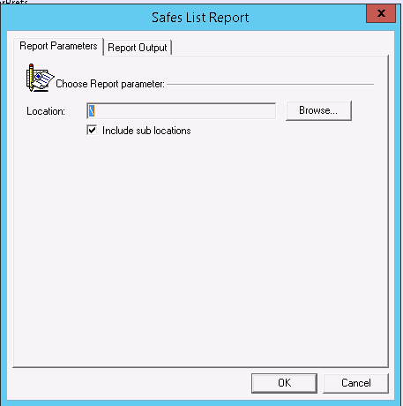

**Owner’s list:**

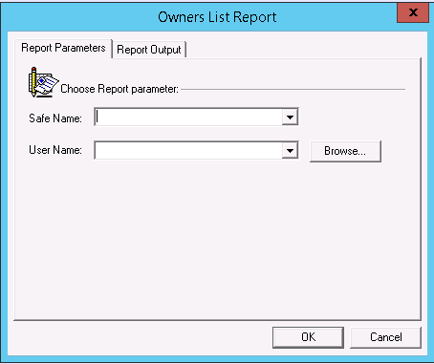

**Safe Activities Report:**

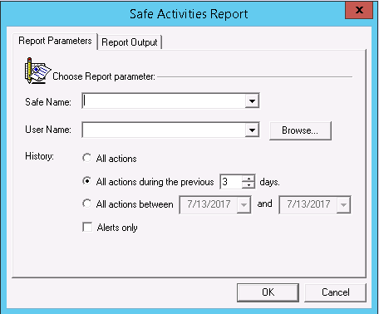

**Active\Non Active safes:**

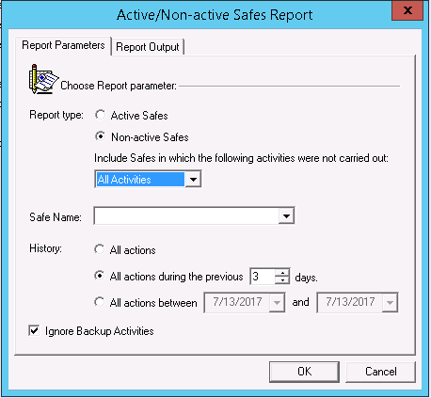

**Entitlement Report:**

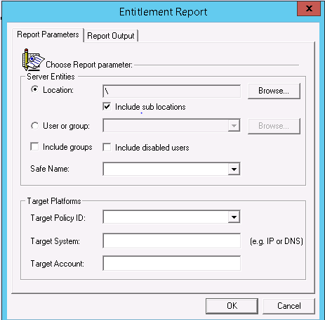

**License capacity report:**

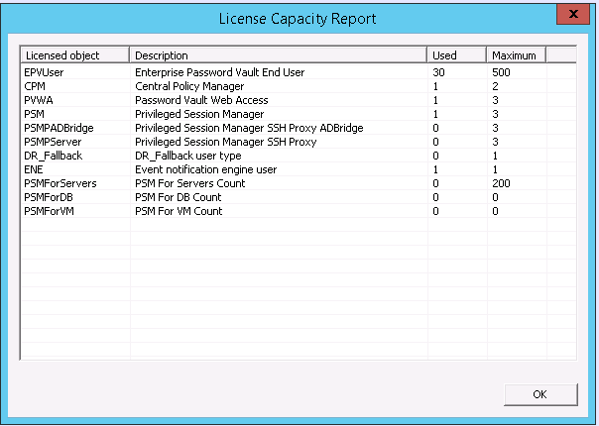

**Users list report:**

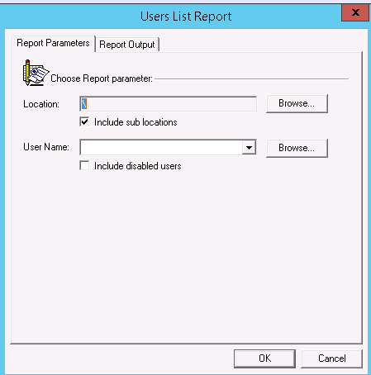

**Users Activities:**

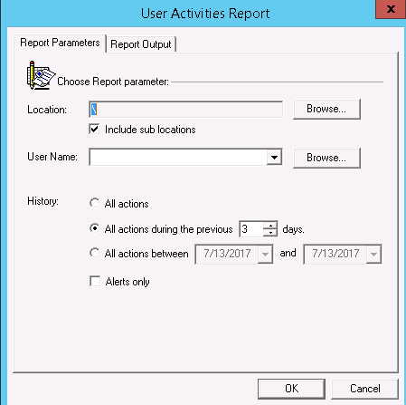

**Active\Non Active Users:**

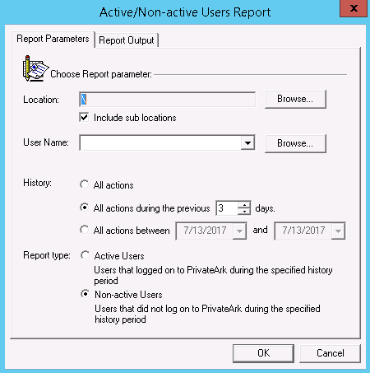

# Administering Safes in Cyberark

To create Safe in Cyberark:

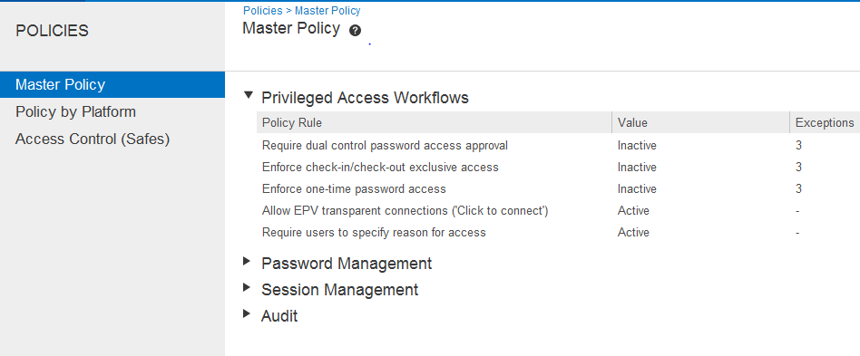

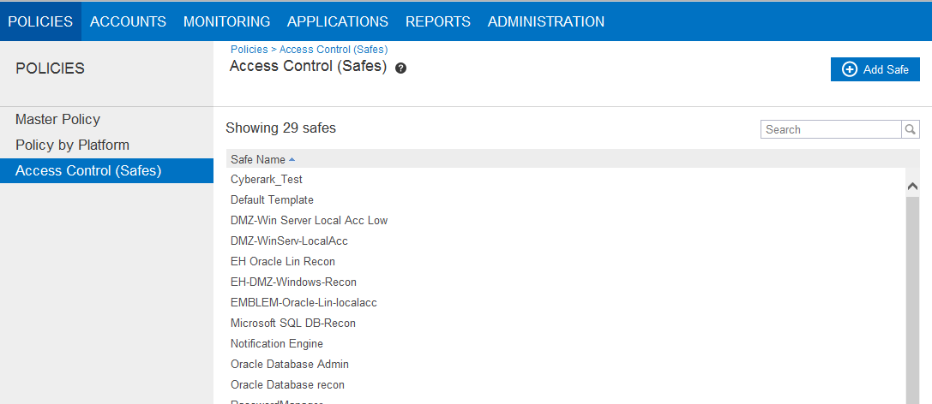

## Updating Safe Permissions

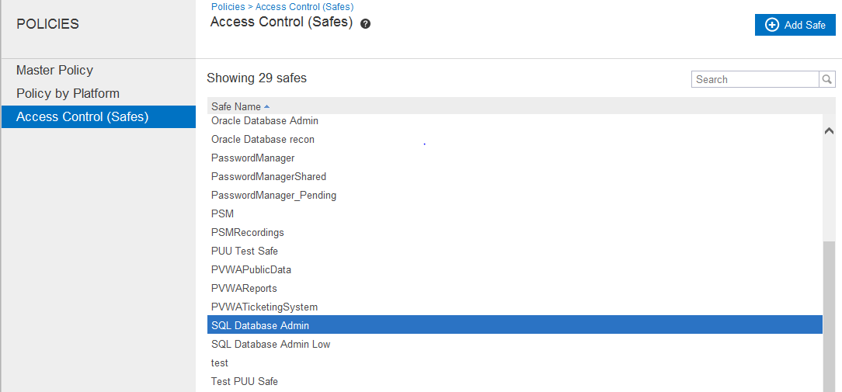

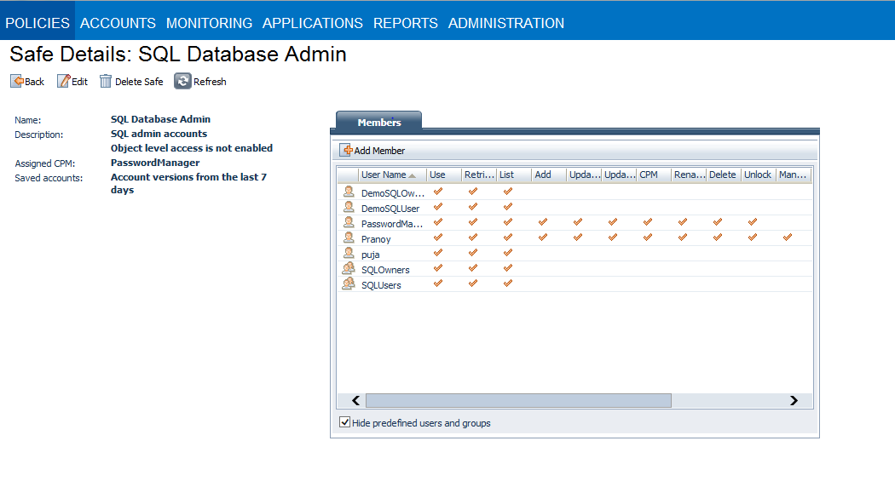

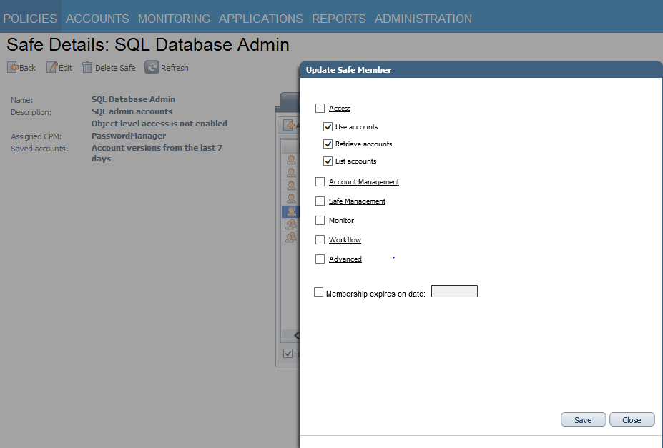

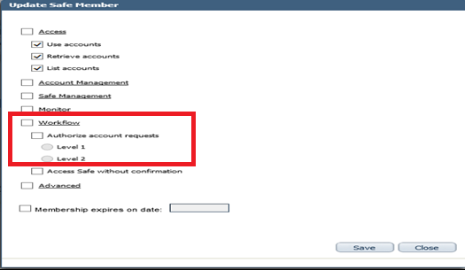

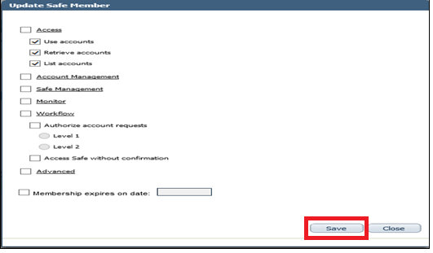

## Changing a Password via the CPM